**Fracas at Forest Hills MBTA station ends with**

**four arrests**

**By John R. Ellement** Globe Staff, September 16, 2014, 9:14 a.m.

**7**

An 18-year-old teenager and three juveniles were arrested by MBTA Transit Police after they allegedly engaged in a fight at the Forest Hills station Tuesday morning while they were transiting to their high schools.

Transit police Lieutenant Richard Sullivan said the four teens began to argue on the mezzanine of the Jamaica Plain station at about 7:45 a.m. The words escalated into a fight that Transit police brought to a halt by using pepper spray, Sullivan said.

Two of the combatants were treated and released from area hospitals for pepper spray exposure, he said. All four are charged with assault and battery and affray, Sullivan said.

Advertisement



Transit police were at the station through the department’s StopWatch program that deploys police, probation officers, and school officials to major transit stops to prevent violence.

[John R. Ellement can be reached at ellement@globe.com. Follow him on Twitter @JREbosglobe.](mailto:JohnR.Ellementcanbereachedatellement@globe.com.FollowhimonTwitter@JREbosglobe)

**Show comments**

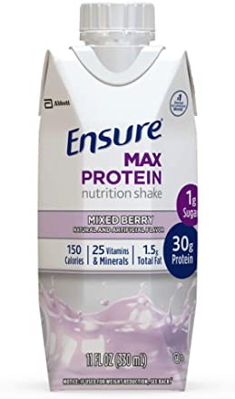

*30g protein and nutrients to support immune health*

Ensure Max Protein Nutritional Shake with 30g of…

1,087

$ 26.91

Add to Cart

# BOSTON GLOBE VIDEO

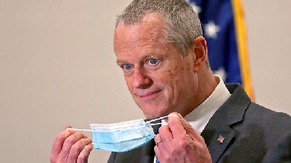

2:23

Baker announces ‘VaxMillions’ lottery program SHARE

Governor Charlie Baker announced residents who are fully vaccinated against COVID-19 will have the chance to win $1 million in a special Lottery sweepstakes. (Photo by Matt Stone/Boston Herald via AP)

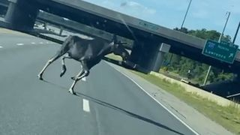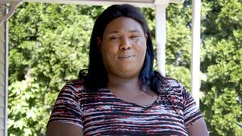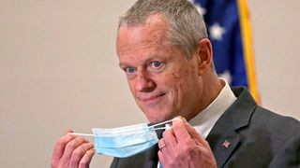

**Baker announces ‘VaxMillions’ lottery program**

**NOW PLAYING**

**Moose spotted on Route 3 in Chelmsford**

**What Black liberation means to me: Athena Vaughn**

# SEE MORE VIDEOS

**MOST POPULAR ON BOSTONGLOBE.COM**

1. Life sciences is poised to be Boston’s dominant industry. Has the area become the Silicon Valley of biotech?
2. Some lawmakers want to ban critical race theory in schools. So, what is it?
3. Is there something wrong with the air in South Portland, Maine?
4. Message in a bottle, tossed into the sea in Rhode Island, found in Azores
5. How Massachusetts communities are celebrating the state’s first official Juneteenth
6. UMass Lowell to remain closed Wednesday while investigating ‘cybersecurity incident’
7. Death penalty should be reinstated for Tsarnaev in Boston Marathon bombings case, Biden administration tells Supreme Court
8. Baker announces ‘VaxMillions’ lottery program, offering $1 million cash prizes to boost vaccination rates
9. Coolidge Corner Theatre gets go-ahead for major expansion
10. A treasure map for an American tyrant



**VIEWS FROM OUR COLUMNISTS**

**YVONNE ABRAHAM**

Energy efficiency is a low-hanging fruit to combat climate change. So why can’t everyone get access to it?

**KEVIN CULLEN**

Bill Bratton on American policing and the challenge facing the Boston Police Department

**THOMAS FARRAGHER**

A salute across the ages to an old squad leader

**SHIRLEY LEUNG**

A working mother’s manifesto: Pandemic provides a once-in-a-generation chance to course correct how we work

**JENEÉ OSTERHELDT**

The pride I carry with me: Karim

**ADRIAN WALKER**

‘The best Boston movie no one’s ever seen’: ‘Blue Hill Avenue’ at 20

**MORE ON GLOBE.COM**

## SPONSORED BY: SUB- ZERO, WOLF, AND COVE

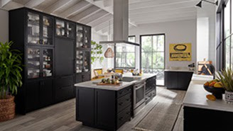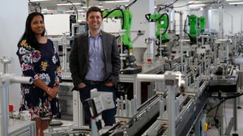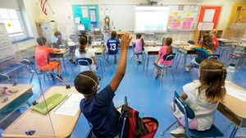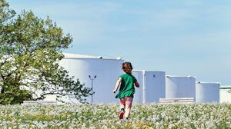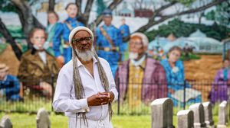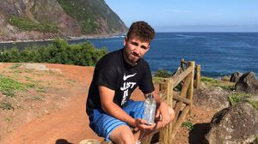

### Outfit your designer kitchen with this guide to high-end appliances

From choosing a cooktop to refrigeration options, learn how to select the right style for your space.

## INNOVATION ECONOMY

### Life sciences is poised to be Boston’s dominant industry. Has the area become the Silicon Valley of biotech?

Since December, you can find six major indications that Boston is the undisputed center of the life sciences industry, a place where ideas and products that change — and save — people’s lives around the world originate.

## THE GREAT DIVIDE

### Some lawmakers want to ban critical race theory in schools. So, what is it?

As national debate over race-related curriculums rages on, here is a lesson on the subject and the controversy surrounding it.

## GLOBE MAGAZINE

### Is there something wrong with the air in South Portland, Maine?

Residents have lived near more than 100 massive petroleum storage tanks for decades, never really knowing if they’re breathing in dangerous chemicals. Now they’re fighting to find out.

### How Massachusetts communities are celebrating the state’s first official Juneteenth

For more than a century, Juneteenth was a Texan holiday, then a Southern holiday, commemorating the anniversary of June 19, 1865, when General Gordon Granger of the Union Army told formerly enslaved people in Galveston they were free. Now it will be celebrated for the first time across the Commonwealth as an official state holiday.

## RI NEWS

### Message in a bottle, tossed into the sea in Rhode Island, found in Azores

The note was written in 2018 by a 13- year-old who was visiting family in Rhode Island.

### A treasure map for an American tyrant

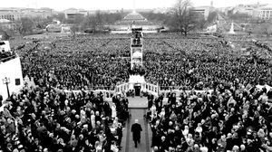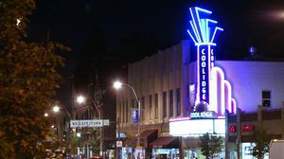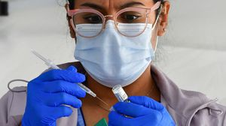

Donald Trump exposed weaknesses that a would-be dictator could exploit to end our democracy. It’s now up to lawmakers, voters, and public officials to prevent that from happening.

## PATRIOTS

### 12 observations from Patriots minicamp, day 2: Mac Jones impresses among QBs, Jalen Mills stands out

Cam Newton was 9 of 17 with one pick

— a nifty sideline theft by Kyle Dugger, who continues to show outstanding range.

### Coolidge Corner Theatre gets go-ahead for major expansion

Brookline officials are reviewing a proposed expansion of the landmark Art Deco cinema that will add two new screens — and over 200 seats — as well as a larger lobby and third-floor community space, with a catering kitchen and outdoor roof deck.

## OPINION

### I got the Johnson & Johnson vaccine. The pause makes me believe in it more.

The worst thing that could happen now is for the recommendation by the FDA and CDC to pause the vaccine’s administration to spur a new wave of vaccine hesitancy.

#### MOST READ IN THIS SECTION

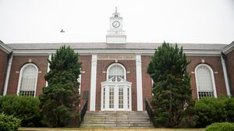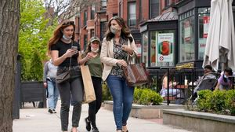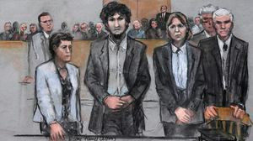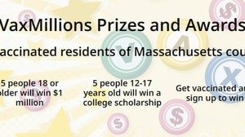

**THE GREAT DIVIDE**

**Some lawmakers want to ban critical race theory in schools. So, what is it?**

**GLOBE MAGAZINE**

**Is there something wrong with the air in South Portland, Maine?**

**How Massachusetts communities are celebrating the state’s first official Juneteenth**

**RI NEWS**

**Message in a bottle, tossed into the sea in Rhode Island, found in Azores**

**UMass Lowell to remain closed Wednesday while investigating ‘cybersecurity incident’**

**The downside of ditching masks: the return of colds, flu**

**Death penalty should be reinstated for Tsarnaev in Boston Marathon bombings case, Biden administration tells Supreme Court**

**Baker announces ‘VaxMillions’ lottery program, offering $1 million cash prizes to boost vaccination rates**

**FOLLOW US**

#### SUBSCRIBE NOW MY ACCOUNT CONTACT MORE

Digital Access / Home Delivery / Gift Subscriptions

Log In /

Manage My Account / Customer Service

Help & FAQs / Globe Newsroom / Advertise

Newsletters / View The EPaper /

Order Back Issues / News In Education / Search The Archives / Privacy Policy / Terms Of Service / Terms Of Purchase / Work At Boston Globe Media /

Do Not Sell My Personal Information

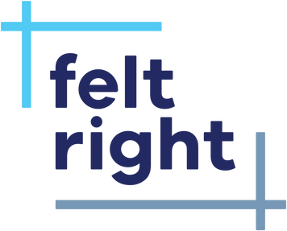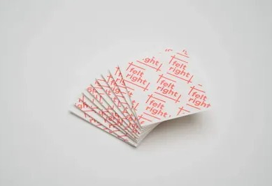

Commerrciiall Grrade Adhessiive T…

Stacked Shiplap Armor Acous…

$9.99

Shop now

$191.76

Lavenderr Bllank Boarrd Acoussttii…

Emerald Slash Board Acoustic…

$89.88

$95.88

**METRO SPORTS BUSINESS & TECH OPINION**

WELCOME, JOHN

**TODAY'S PAPER**

**Summer Fitness Challenge**

**Starts Monday**

Sign up now

©2021 Boston Globe Media Partners, LLC